

Firstname Lastname
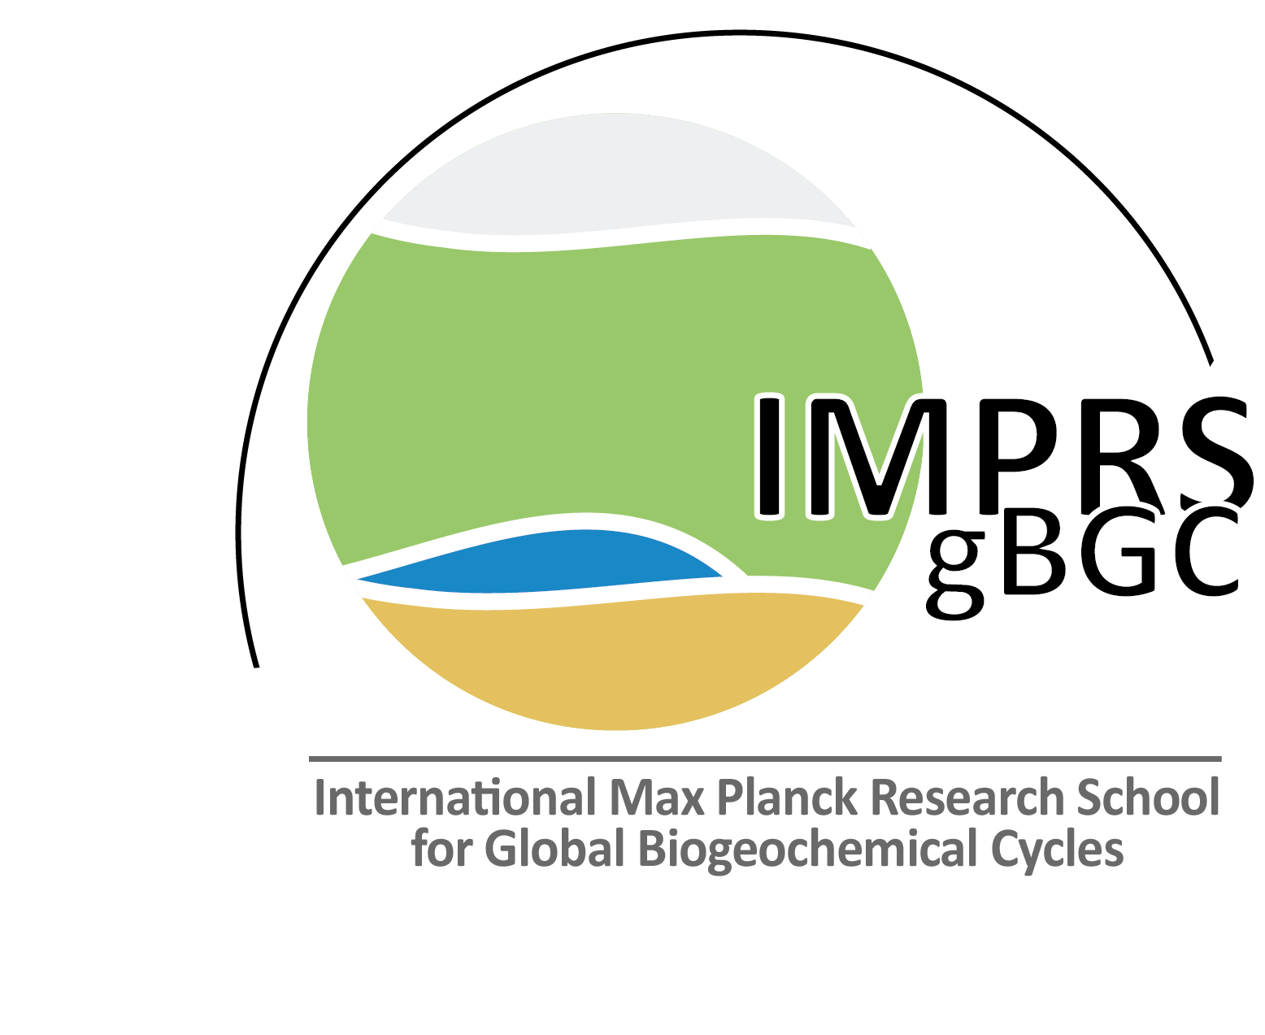

Fulfillment of IMPRS-gBGC requirements so far

as of MONTH, DD, Year

Curricular element |  | credit points (CP) | Min | status
Courses related to global biogeochemical cycles
Overview course* |  | 1 | 1
Core courses, e.g. Atmosphere, ocean and land, Terrestrial biosphere Soil, soil biology and soil hydrology⁽¹⁾ |  | 1 per 5-day course | 2
Skill and elective courses, e.g. Statistics, Modeling, Programming skills, Analytical techniques⁽¹⁾ and external courses, summer schools or workshops |  | 1 per 5-day course | 3
Transferable skills
e.g. Good scientific practice*, Scientific writing, Data visualization, Career planning, Communication skills, Leadership skills, Time and self management⁽¹⁾ |  | 0.2 per course day | 1
Outreach activities
Presentations at international conferences |  | 1 per talk; 0.5 per poster | 1
first author publication in internationally peer-reviewed journal |  | 1 per submitted publication  2 per accepted publication | 1
Non-first-author publication in internat. peer-reviewed journal |  | 1 per non-first-author publication | 0
Public outreach (radio, newspaper, public talk, Long Night of Science, social media, ...) |  | 1 per outreach | 1
Other scientific activities
Research visit at foreign research group |  | 1 per month | 3
Active participation in PhDnet, organization of scientific events, active participation in scientific societies, teaching, …  PhD representative  Supervision of Bachelor / Master thesis |  | depending on effort  1 per year  1 / 2 per thesis | 0
Award of an international conference  Review of a publication |  | 1 per award  1 per review
∑ CPs from curricular elements specified above |  |  | 13
Total number of CPs necessary to obtain IMPRS-gBGC certificate |  |  | 20^{(2).}.
* mandatory course for PhD researchers
⁽¹⁾ offered by IMPRS-gBGC
⁽²⁾ The PhD researcher is free to choose together with PAC how to collect the credit points

